KASHIPUR MICHEAL MADHUSUDAN MAHAVIDYALAYA
(PERSONAL PROFILE)
Name: PIJUSH MUKHOPADHYAY 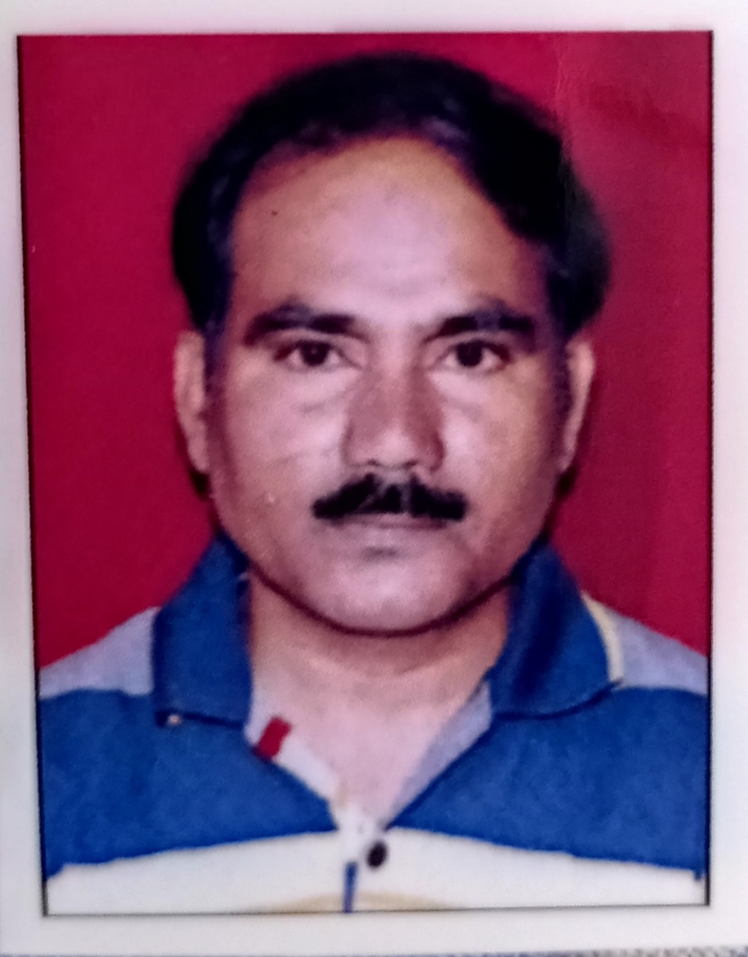
Designation: SACT - II
Department: GEOGRAPHY
Date of Joining: 06/04/2005
e-mail: pijushmukhopadhyay@gmail.com

Educational Qualification:
Graduation: B.A .HONS (GEOGRAPHY).RSM ,COLLEGE,DHANBAD,1997
Post-graduation: M.A. IN (GEOGRAPHY) VBU,HAZARIBAG,2002
M.Phil / Ph.D.
State Level / National / International Conferences /Seminars /Workshops /Webinar Attended:
Paper Presentations in Seminars / Conferences / Webinars
- “Pre-Mitigation Disaster Management: Theoretical Approaches” in the National Seminar on Challenge & Mitigation of Drought in India, Organized by the Department of Geography, 9-10 September 2011, KMMM, Purulia, W.B.
- “Disaster Preparedness, Relief and Recovery in India”, in the 36th Annual Conference of Bengal Economic Association, organized by the Department of Economics, Kashipur M. M. Mahavidyaya, Purulia during 11-12 March, 2016.

Participation in Seminars / Conferences / Training Programmes / Workshop / Webinars
- National Seminar - Challenge & Mitigation of Drought in India, 9-10 th Sep.2011,
KMMM, Purulia ,WB
- Two Decades of Economics Reforms in India -24th sep. 2011,KMMM, Purulia WB
- Challenges of C common Property Resources ,22-23 sep.2011 KMMM, Purulia ,WB
- Role of Research in Higher Education ,Feb,16th 2015, KMMM, Purulia ,WB
- One Day state level seminar -Exposure To Toxic In Daily Life, 24th August 2016, Nistarini College ,Purulia ,WB
- One Day International Seminar on “Environment, Public Health & GIS”, 26th August 2016.
- Two Days GPS Training Programme ,15th-16th Feb.2017,TDB College, Raniganj ,Burdwan ,WB.
- Workshop on CBCS In Geography ,Nistarini College 29th & 30th Nov, 2017.Purulia .WB
- Workshop on “Remote Sensing ,GIS & Field -Work 2nd & 3rd April. 2019
- International webinar of “Climate Talk” by Youth Net Bangladesh and Bhugol O Paribesh .18th June 2020
- “Environment Sustainability : Land ,Water & Ecosystem” 31st August, 2020 KMMM, Purulia, WB
- One Day National Webinar on “ Sustainable Development Goals & Covid -19, 9th Sep. 2020, )Purulia, WB ,
- " GREEN AND INCLUSIVE GROWTH FOR SUSTAINABLE DEVELOPMENT"105th.Annual Conference of the Indian Economic Association, 27-29th. December 2022 at Shyama Prasad Mukherjee University, Ranchi
List of Research Papers published in National / International Journals / Books / Conference Proceedings with ISBN / ISSN / Impact Factor:
A) Books: NA
B)Journals: NA
C) Book Chapters: “Impact of Industrial Effluents on Physico-chemical Characteristics of Soil in Adjoining Areas of Cement Industry Located near Asansol, Paschim Bardhaman District (W.B.), India”, Islam, N., Haque, J., and Miah, C. (eds): Thought of Scientific Research: International Book of Multidisciplinary Studies, ISBN 978-1-913482-13-8, pp. 11-18, Rubicon Publications, London.
C) Conference Proceedings: NA
Awards and Recognition: NA

Areas of Specialization in Research / Teaching:
Specialization in Teaching: Geology & Geo-morphology
In Research: NA

Teaching:
Theory: 1) Physical Geography 2) Regional Geography 3) Disaster Management 4) Environmental Geography 5) Social Geography
Practical: 1) Cartograms & Thematic Mapping 2) Topographical Maps
Excursion / Field Survey: Conduct students excursions; Supervision of undergraduate field reports
"SOCIO ECONOMIC FIELD SURVEY"(3Rd. Sem. Hons.) At Kashipur,Purulia, West Bengal , 2023 Month of May.
Invited Lecture / Foreign Visit: NA

Other Academic Activities: NA

Board of Studies:
Course Design:
Paper Setter:

Administrative Activities:

- Member of Cultural Committee

Associated with Learned Bodies / Association / Society / Organization: NA

